-- Andre Ceschia: 501156295

-- Numair Jaan: 501113345

-- Ty Tsiamala: 501168084

-- This query shows all beneficiaries in the database and whose accounts they can access

SELECT

U1.user_id as benificary_id,

U1.first_name as benificary_first_name,

U1.last_name as benificary_last_name,

U2.first_name as grantor_first_name,

U2.last_name as grantor_last_name

FROM users U1

JOIN benificary B on U1.user_id=B.benificary_id

JOIN users U2 on B.grantor_id=U2.user_id;

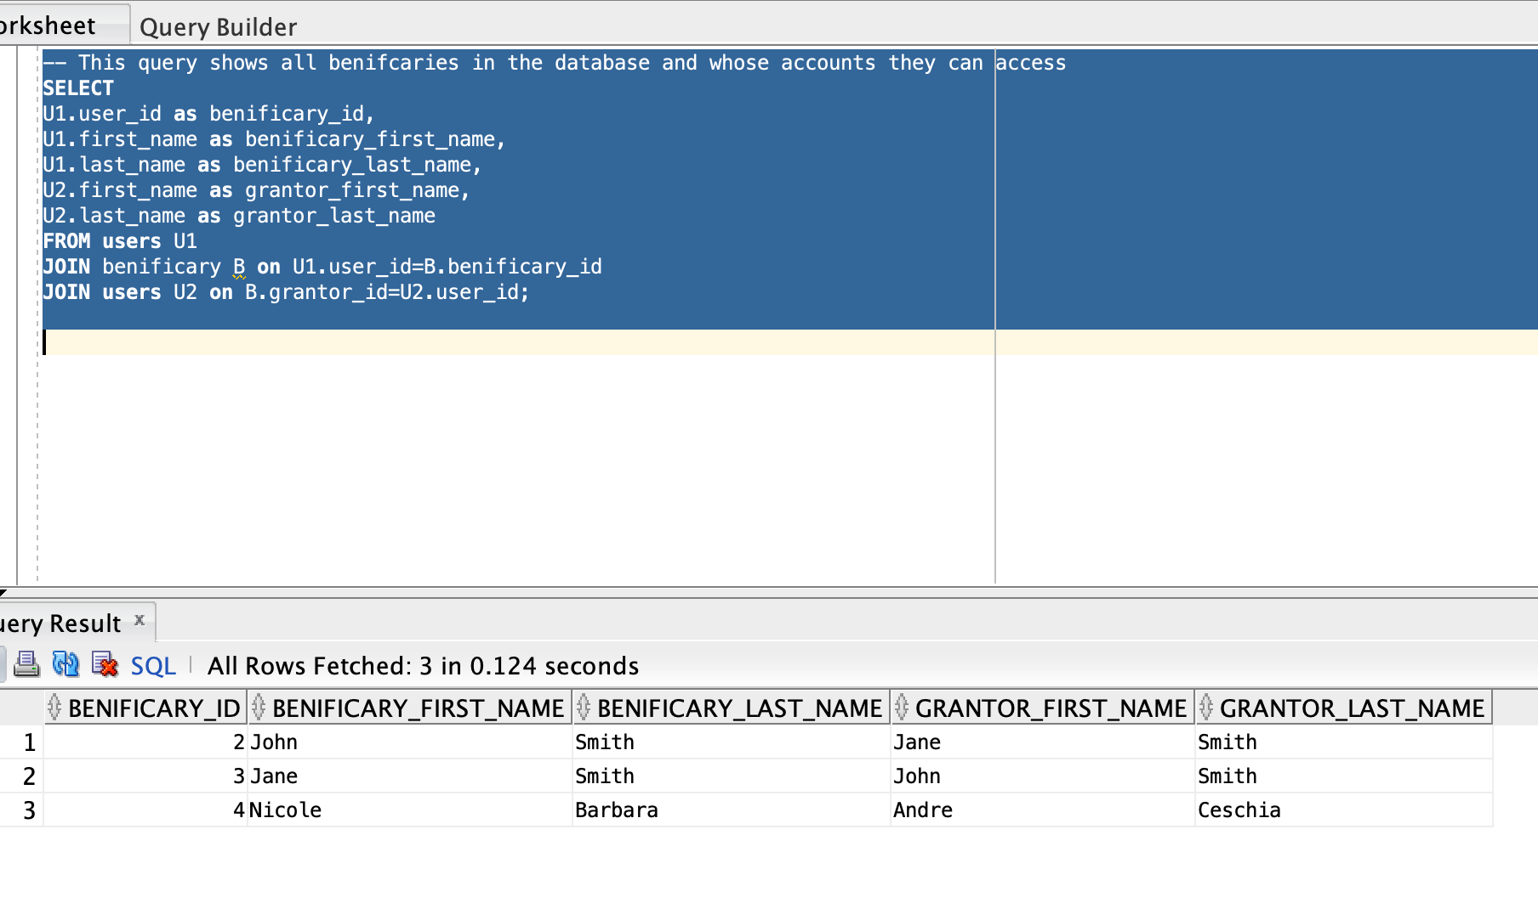

-- This query shows the total balance in all of a users accounts

-- sorted by balance

-- i.e. sum of chequing balance, savings balance, credit debt

SELECT

U.user_id, U.first_name, U.last_name, sum(balance) as Total_Balance

FROM users U

JOIN account A on A.user_id=U.user_id

GROUP BY (U.user_id, U.first_name, U.last_name)

ORDER BY Total_Balance DESC;

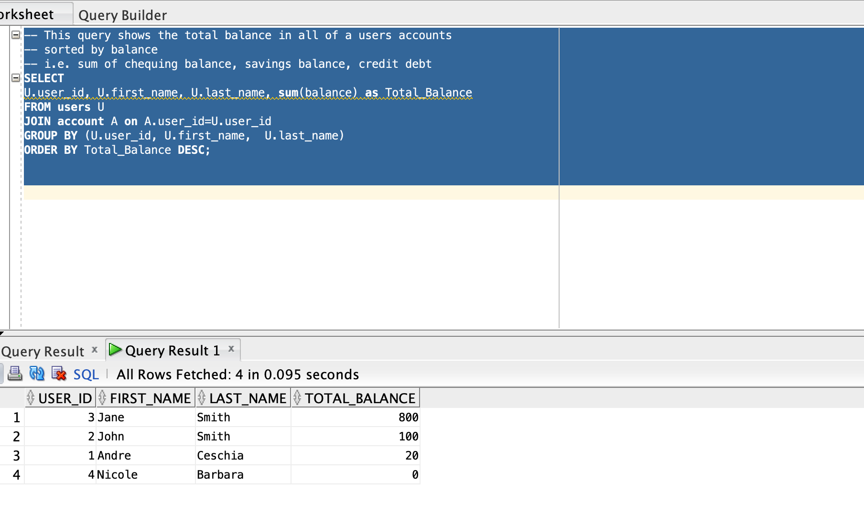

-- This query shows the balance in all users rewards account

SELECT U.user_id, U.first_name, U.last_name, RA.balance

FROM rewards_account RA

JOIN users U on RA.user_id=U.user_id;

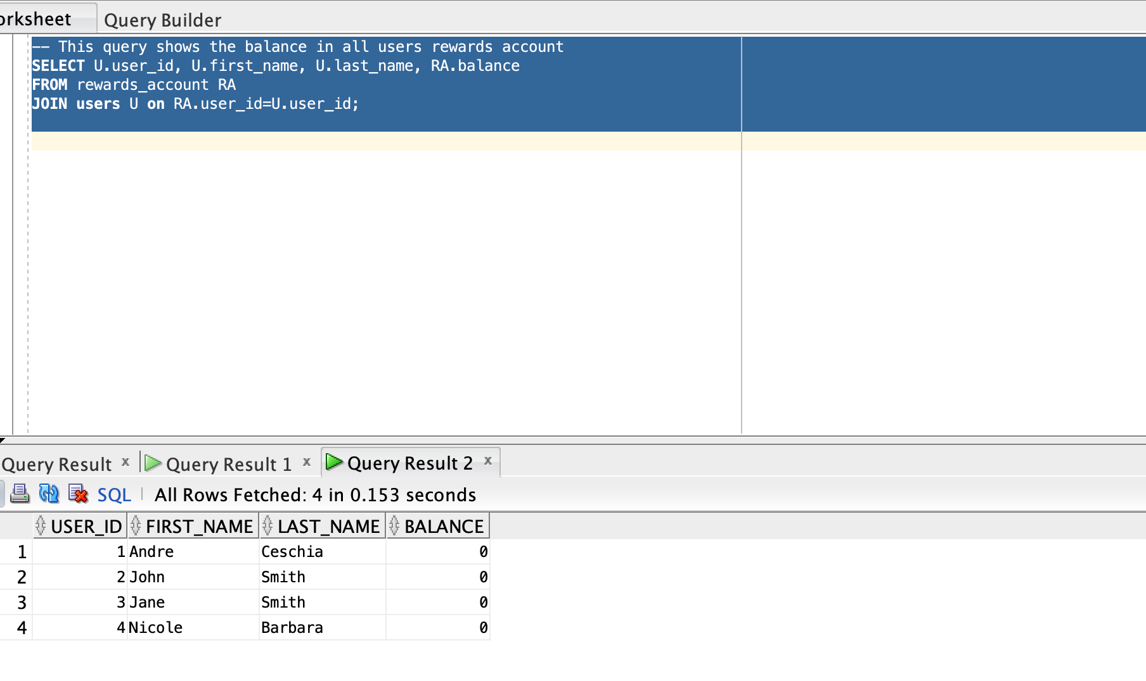

-- This query shows us the savings accounts (and their owners) with the nearest compound date

-- If 2 accounts have the same compound date, sort by balance

SELECT U.user_id, A.account_id, U.first_name, U.last_name, A.balance, SA.compound_date

FROM savings_account SA

JOIN account A ON A.account_id=SA.account_id

JOIN users U ON U.user_id=A.user_id

ORDER BY SA.compound_date ASC, A.balance DESC;

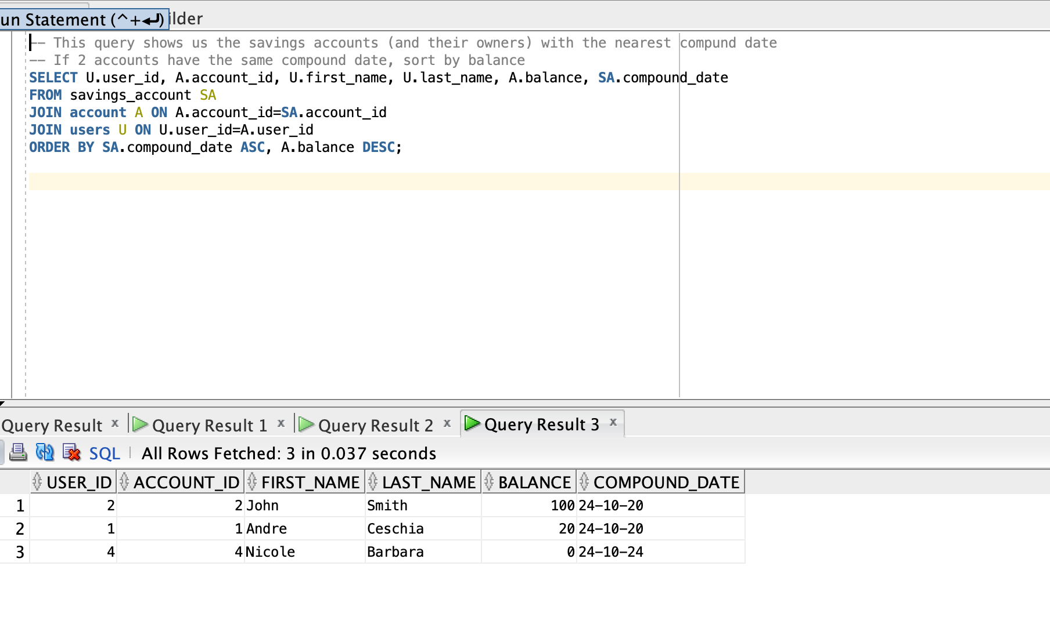

-- This query shows us all chequing accounts sorted by balance ascending and their owners

SELECT U.user_id, A.account_id, U.first_name, U.last_name, A.created, A.balance

FROM chequing_account CA

JOIN account A on A.account_id=CA.account_id

JOIN users U on U.user_id=A.user_id

ORDER BY A.balance DESC;

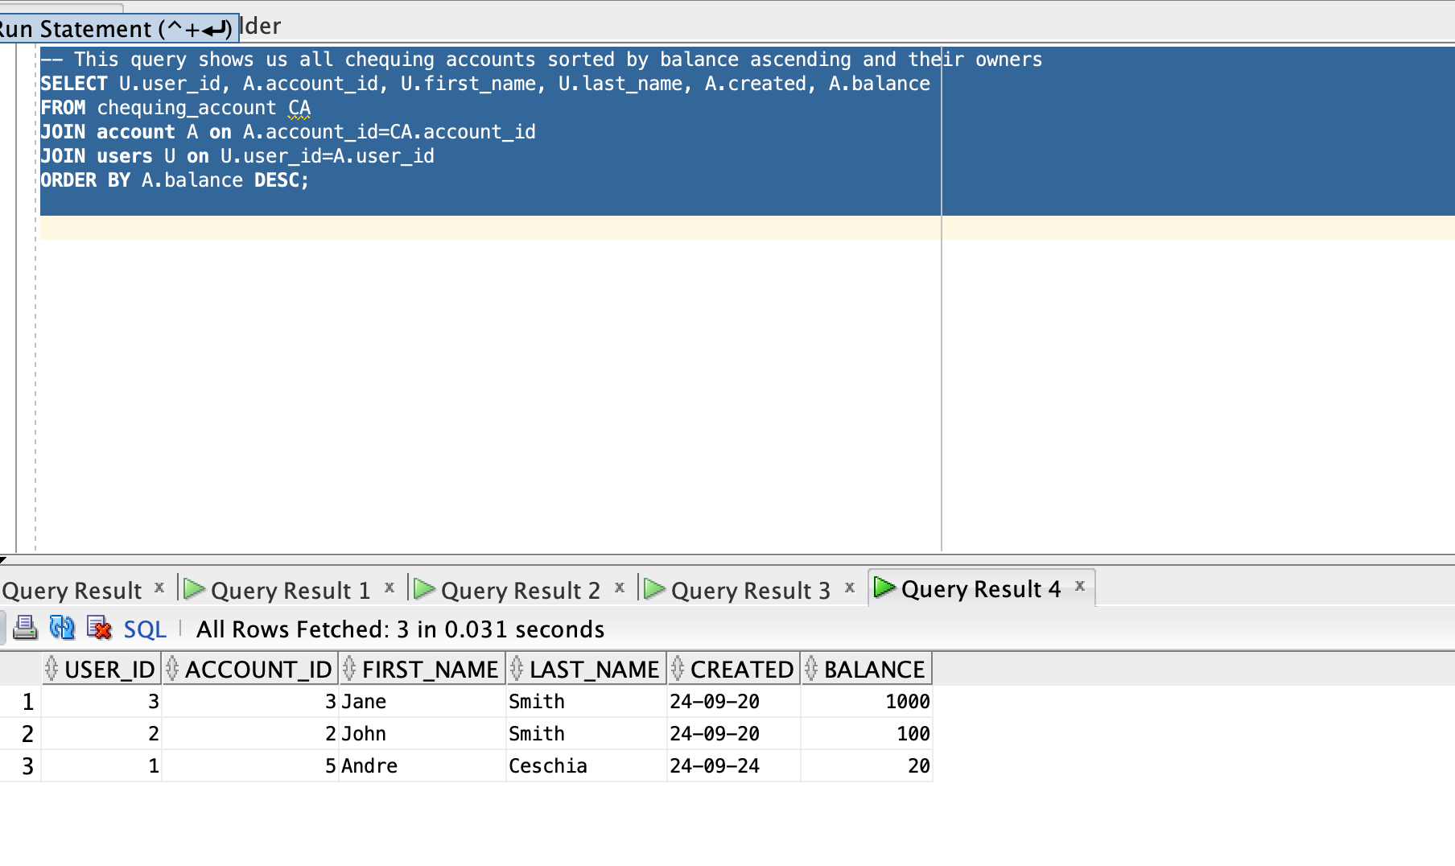

-- This query shows us all users who currently owe money on their credit card

-- sorted by nearest due date

SELECT U.user_id, A.account_id, U.first_name, U.last_name, A.balance, CA.due_date

FROM credit_account CA

JOIN account A ON a.account_id=CA.account_id

JOIN users U on A.user_id=U.user_id

WHERE A.balance < 0

ORDER BY CA.due_date ASC, A.balance ASC;

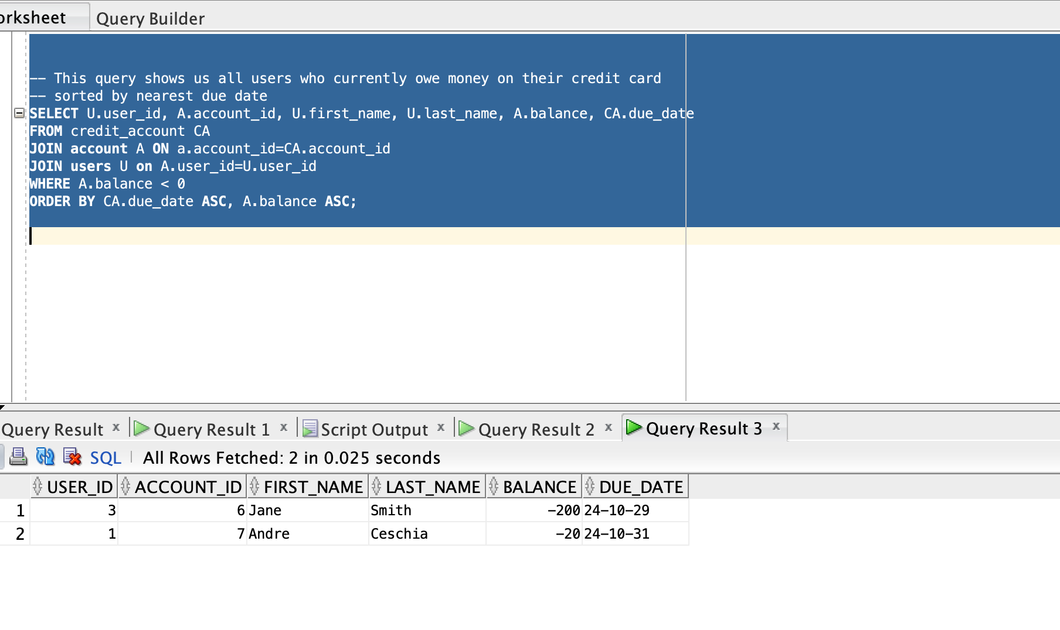

-- What is the name and phone number of everyone who does not live in toronto

SELECT U.user_id, U.first_name, U.last_name, CI.phone_number

FROM contact_info CI

JOIN users U ON U.user_id=CI.user_id

WHERE City <> 'Toronto';

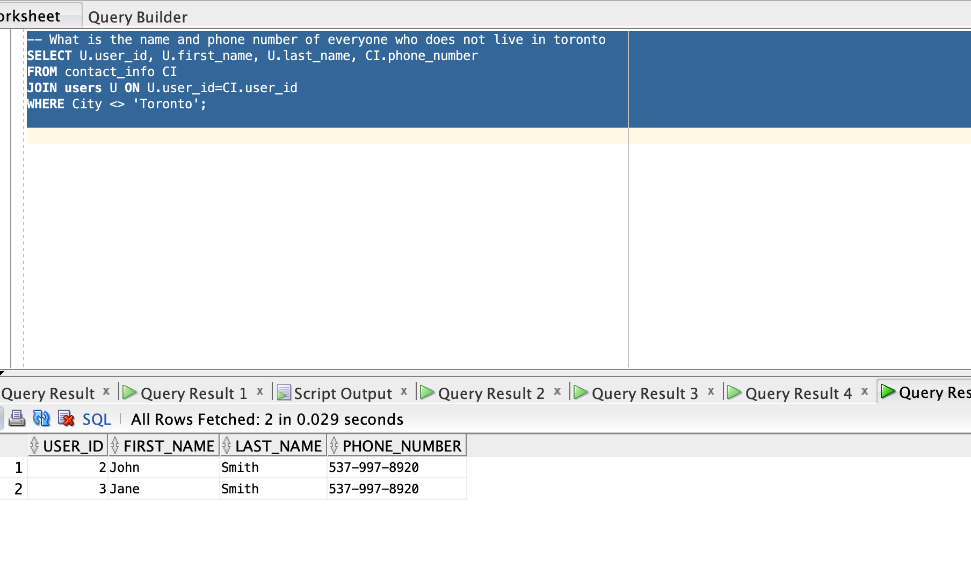

-- How many accounts does each person own?

-- Sorted by total accounts

SELECT U.user_id, U.first_name, U.last_name, COUNT(A.account_id) as Total_Accounts

FROM account A

JOIN users U ON A.user_id=U.user_id

GROUP BY (U.user_id, U.first_name, U.last_name)

ORDER BY Total_Accounts DESC;

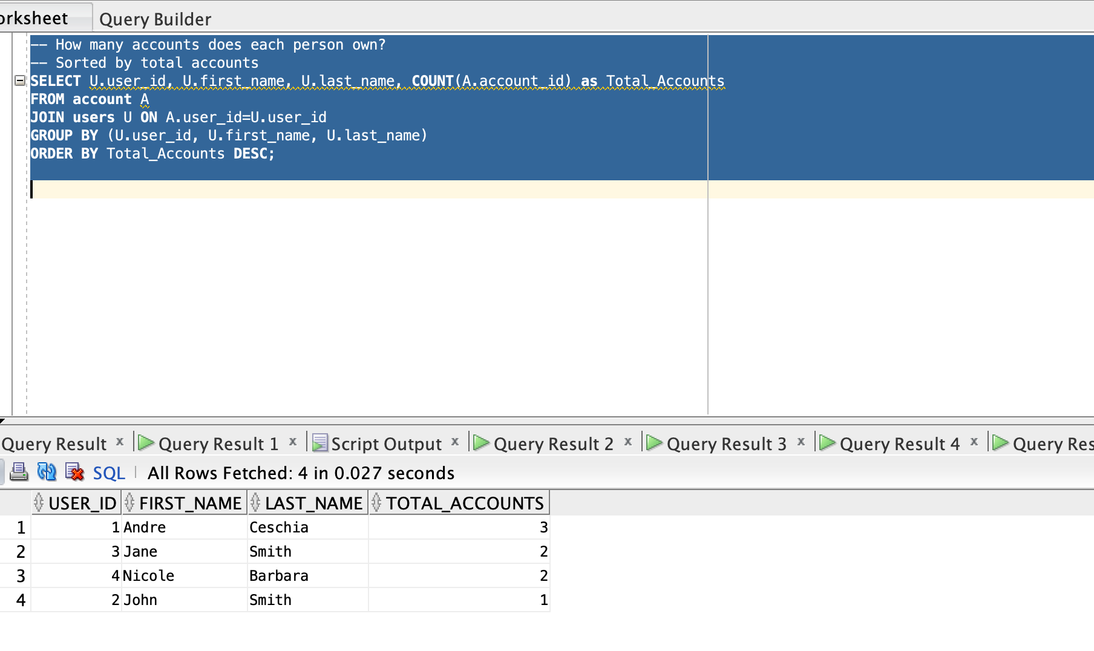

-- What transactions has each person made on their accounts

-- What is their full name and email in case they need to contacted for suspected fraud

-- Sorted by user_id so a user’s transactions are grouped together

SELECT U.user_id, A.account_id, U.first_name, U.last_name, CI.email, T.amount, T.description

FROM transactions T

JOIN account A ON T.account_id=A.account_id

JOIN users U ON U.user_id=A.user_id

JOIN contact_info CI ON ci.user_id=U.user_id

ORDER BY U.user_id ASC;

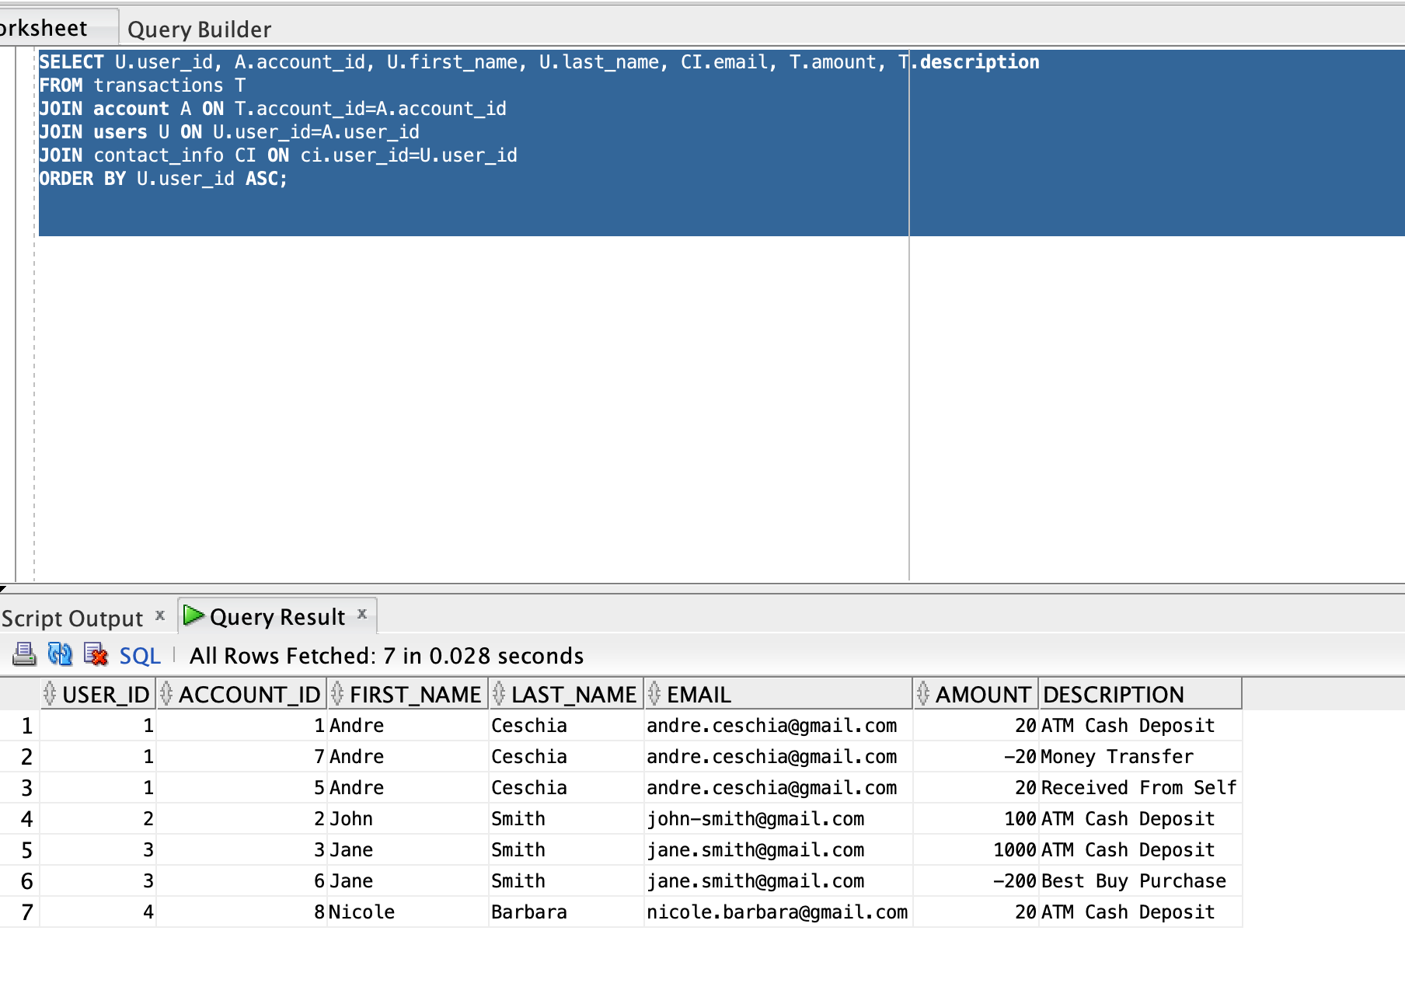

– View access

SELECT * FROM benificary_access

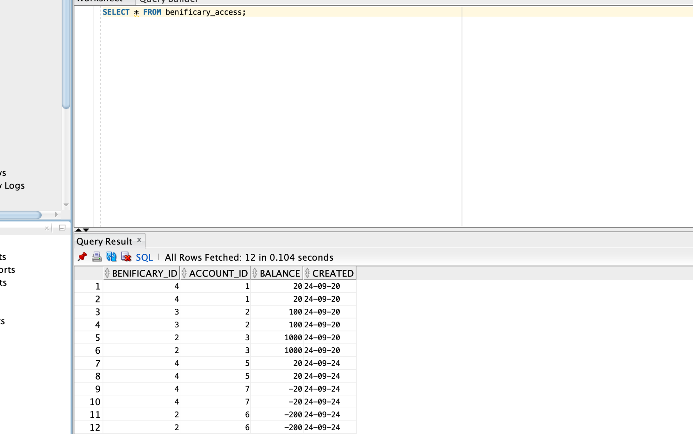

SELECT * FROM overdue_credit;

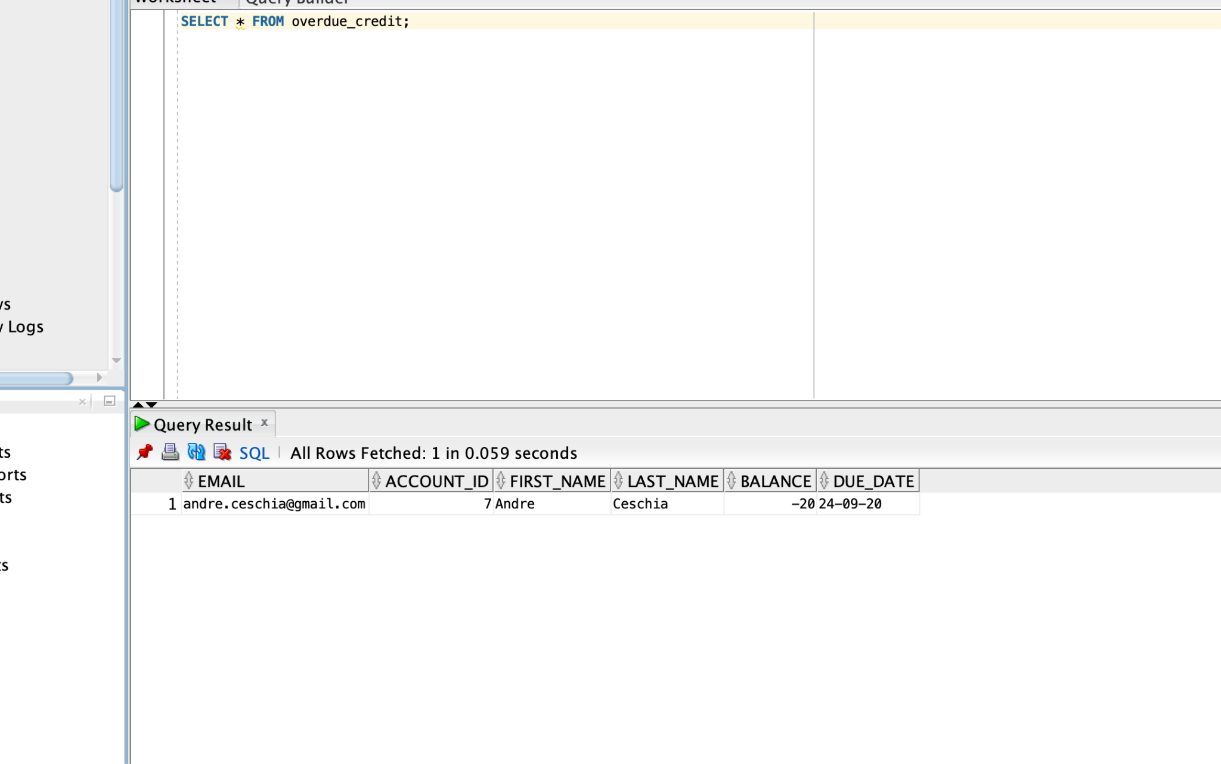

SELECT * FROM user_totals;

